**AW00006**

**Task 1**

You should spend about 20 minutes on this task

**The graph below gives information on the number of participants for different activities at one social centre in Melbourne, Australia for the period 2000 to 2020.**

Summarise the information by selecting and reporting the main features making comparisons where relevant.

Write at least 150 words.

**Task 2**

Write about the following topic:

You should spend about 40 minutes on this task.

**In the past most working people had only one job however nowadays more and more people have more than one job at the same time**

**What are the reasons for this development?**

**What are the advantages and disadvantages of having more than one job?**

Give reasons for your answer and include any relevant examples from your own knowledge or experience.

Write at least 250 words.

**AW00007**

**Task 1**

You should spend about 20 minutes on this task.

**The diagram below shows how a biofuel called ethanol is produced.**

Summarise the information by selecting and reporting the main features making comparisons where relevant.

Write at least 150 words.

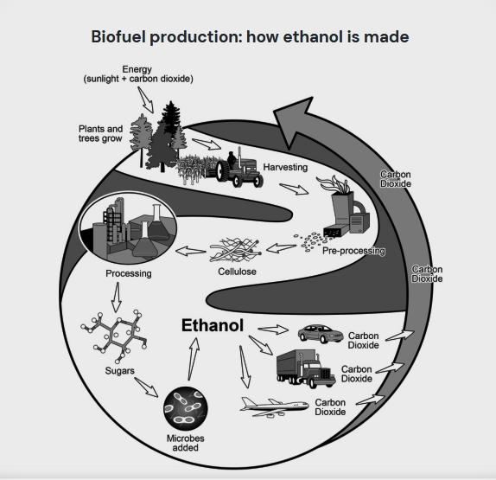

**Task 2**

Write about the following topic:

You should spend about 40 minutes on this task.

**Some people think that competition at work at school and in daily life is good thing, others believe that we should try to cooperate more rather than competing against each other.**

**Discuss both views and give your opinion**

Give reasons for your answer and include any relevant examples from your own knowledge or experience.

Write at least 250 words.

**AW00008**

**Task 1**

You should spend about 20 minutes on this task

**The chart below shows the number of households in the US by their annual income in 2007, 2011, and 2015.**

Summarise the information by selecting and reporting the main features making comparisons where relevant.

Write at least 150 words.

**Task 2**

Write about the following topic:

You should spend about 40 minutes on this task.

The working week should be shorter and workers should have a long weekend do you agree or disagree

Give reasons for your answer and include any relevant examples from your own knowledge or experience.

Write at least 250 words.

**AW00008**

**Task 1**

You should spend about 20 minutes on this task

**The diagram below shows the floor plan of a public library 20 years ago and how it looks now.**

Summarise the information by selecting and reporting the main features making comparisons where relevant.

Write at least 150 words.

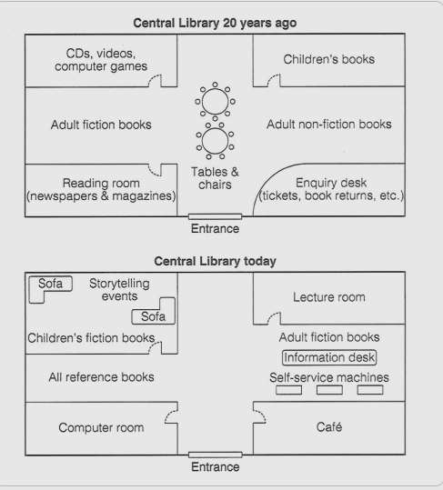

**Task 2**

Write about the following topic:

You should spend about 40 minutes on this task.

**Some universities dance want to learn about other subjects in addition to the main subjects others believe it is more important to give all they are time and attention to study for qualification.**

**Discuss both these views and give your own opinion.**

Give reasons for your answer and include any relevant examples from your own knowledge or experience.

Write at least 250 words.

**AW00009**

**Task 1**

You should spend about 20 minutes on this task

The line graph below shows the household recycling rates in three different countries between 2005 and 2015.

Summarise the information by selecting and reporting the main features making comparisons where relevant.

Write at least 150 words.

**Task 2**

Write about the following topic:

You should spend about 40 minutes on this task.

**In many countries, people are now living longer than ever before. Some people say an aging population creates problems for governments. Other people think there are benefits if society has more elderly people.**

**To what extent do the advantages of having an aging population outweigh the disadvantages?**

Give reasons for your answer and include any relevant examples from your own knowledge or experience.

Write at least 250 words.

**AW00010**

**Task 1**

You should spend about 20 minutes on this task

**The chart shows the number of mobile phones and landlines per 100 people in selected countries.**

Summarise the information by selecting and reporting the main features making comparisons where relevant.

Write at least 150 words.

**Task 2**

Write about the following topic:

You should spend about 40 minutes on this task.

**Nowadays children are experiencing increased educational, social and commercial pressure.**

**What are the reasons for this?**

**What is a solution to reduce the pressure?**

Give reasons for your answer and include any relevant examples from your own knowledge or experience.

Write at least 250 words.

**AW00011**

**Task 1**

You should spend about 20 minutes on this task

**The line graphs below show the production and demand for steel in million tonnes and the number of workers employed in the steel industry in the UK in 2010.**

Summarise the information by selecting and reporting the main features making comparisons where relevant.

Write at least 150 words.

**Task 2**

Write about the following topic:

You should spend about 40 minutes on this task.

**People are living in a 'throwaway society', using things for a short time and then throwing them away.**

**What are the causes of this?**

**What problems does it lead to?**

Give reasons for your answer and include any relevant examples from your own knowledge or experience.

Write at least 250 words.

**AW00012**

**Task 1**

You should spend about 20 minutes on this task

The table below shows the changes in exports in billions 2009 and 2010.

Summarise the information by selecting and reporting the main features making comparisons where relevant.

Write at least 150 words.

|  |  |  |  |
| --- | --- | --- | --- |
| $ billions | 2009 | 2010 | Changes |
| Equipment | 10.3 | 11.6 | 13% |
| Telecommunication | 7.9 | 12.7 | 61% |
| Clothing | 6 | 5 | -17% |
| Manufacturing | 5.5 | 4 | -27% |
| Metals | 2.3 |  | 122% |
| Overall | 32 |  | 20% |

**Task 2**

Write about the following topic:

You should spend about 40 minutes on this task.

**It is important for everyone, including young people, to save money for their future.**

**To what extent do you agree or disagree with this statement?**

Give reasons for your answer and include any relevant examples from your own knowledge or experience.

Write at least 250 words.

**Following papers upload as final exam**

**AW00013**

**Task 1**

You should spend about 20 minutes on this task

**The diagrams below show a structure that is used to generate electricity from wave power.**

Summarise the information by selecting and reporting the main features making comparisons where relevant.

Write at least 150 words.

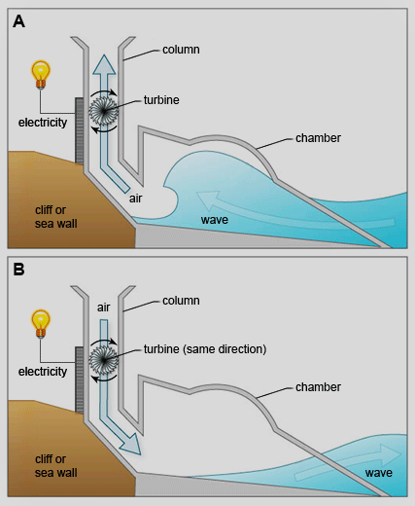

**Task 2**

Write about the following topic:

You should spend about 40 minutes on this task.

**Interviews form the basic selecting criteria for most large companies. However, some people think that the interview is not a reliable method of choosing whom to employ.**

**To what extent do you agree or disagree?**

Give reasons for your answer and include any relevant examples from your own knowledge or experience.

Write at least 250 words.

**AW00014**

**Task 1**

You should spend about 20 minutes on this task

**The graph below shows percentages of types of waste that were recycled in a town between 2000 and 2010.**

Summarise the information by selecting and reporting the main features making comparisons where relevant.

Write at least 150 words.

**Task 2**

Write about the following topic:

You should spend about 40 minutes on this task.

**Today many teenagers rely greatly on technology when learning.**

**Is this a positive or negative development?**

Give reasons for your answer and include any relevant examples from your own knowledge or experience.

Write at least 250 words.

**AW00015**

**Task 1**

You should spend about 20 minutes on this task

**The line graph gives information about percentage changes in total crime arrests for persons under 18 by locality in USA, 1995-1998.**

Summarise the information by selecting and reporting the main features making comparisons where relevant.

Write at least 150 words.

**Task 2**

Write about the following topic:

You should spend about 40 minutes on this task.

**Some people think that developing countries need financial help form international organization. Others think that practical aid and advice that is needed.**

**Discuss these views and give your own opinion.**

Give reasons for your answer and include any relevant examples from your own knowledge or experience.

Write at least 250 words.